Tutorial

Keysight™ MSO X 3012A Digital Channels

This tutorial was authored by J. M. Schmidt, M. Abdulgader and Dr. G. Serpen using technical literature published by the Keysight Technologies Inc., which retains the copyright.

This document is intended for instructional purposes at the Electrical Engineering and Computer Science Department of the University of Toledo.

Revision: April 2017

# Keysight Mixed-Signal Oscilloscope (MSO) – Model X3012A

This document presents a tutorial on using the digital channels of the Keysight X 3012A Mixed Signal Oscilloscope (MSO). The front view of the MSO is presented in Figure 1. The X 3012A is shown in Figure 1 with a single channel of analog information on the upper half of the display and several channels of digital information on the lower half of the display.

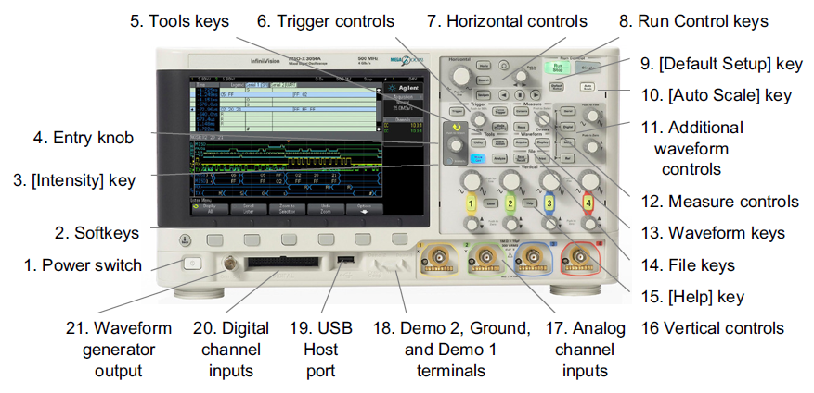

**Figure 1. Front view of Keysight X3012A Mixed Signal O’scope**

# Overview

This tutorial aims to cover several introductory areas of digital logic signal observation and analysis. At the completion of this tutorial, you should know how to trigger on a digital signal, probe digital signals (logic levels, frequency and period), adjust a signal display attributes to be meaningful, enter or edit digital input labels, and transfer waveform data to the Keysight BenchVue utility (which is available in Embedded Systems lab) running on a PC for follow-up analysis and processing.

# Safety Considerations

# 

# 

# Tutorial

Let’s start the tutorial by performing the steps in the order given.

* Boot the PC at your station if it is not already on with Windows already booted.
* Turn on the X 3012A by pressing the power button near the lower left corner of the display. The button should remain in the depressed position. To turn the oscilloscope off press the button a second time and the button should stay in the non-depressed position. Press the button a third time to turn on the oscilloscope. As the oscilloscope warms up and the built-in computer self-tests the system, a booting screen as shown in Figure 2 appears with the word Keysight (among other things).

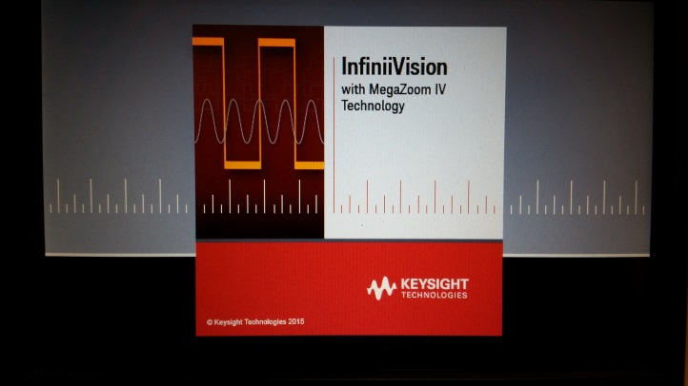

**Figure 2. MSO Boot Screen**

* Figure 3 illustrates the main parameters and adjustments for analysis of logic signals on digital channels on the Keysight X 3012A MSO. The softkeys as shown on the screen image can be accessed by pressing the *Digital* button on the oscilloscope interface.

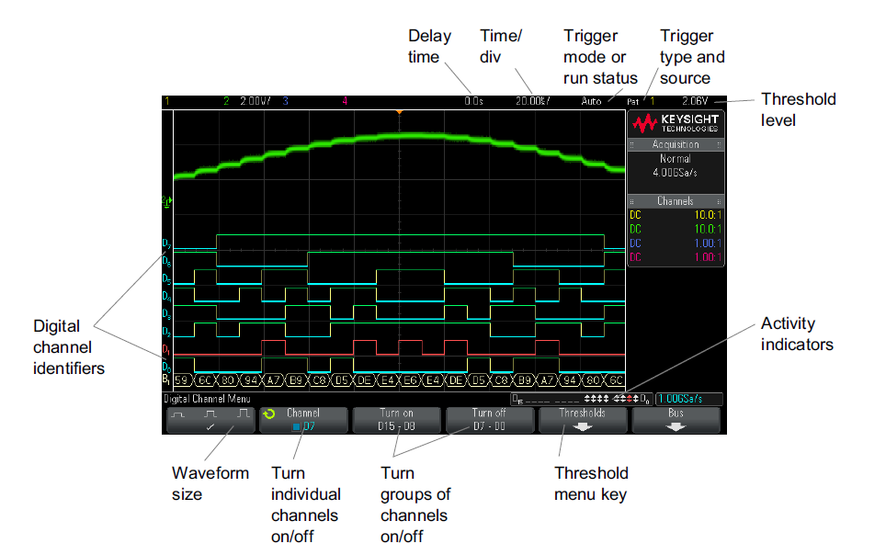**Interpreting the Digital Waveform Display**

**Figure 3. Typical Display with Digital Channels**

* Locate the digital probes that should already be attached to the oscilloscope. If not attach them as shown in Figure 4.

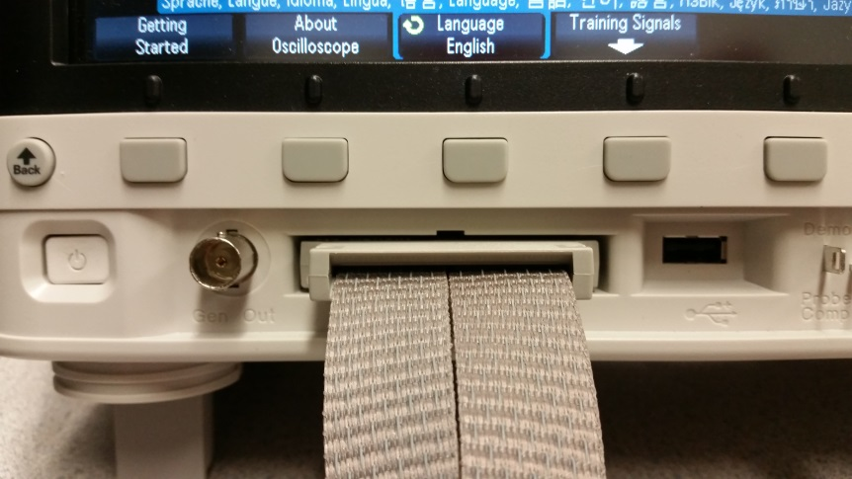

**Figure 4. Digital Probe Connection to MSO**

* The probes look similar to those shown in Figure 5. The MSO has two logic analyzer probes, one for digital inputs zero through seven and the other for eight through sixteen. Both logic analyzer probes are shown below in Figure 6. This tutorial will utilize five of the 16 digital inputs, which will be referred to as D0, D1, D2, D3 and D4 for channels 0, 1, 2, 3, and 4, respectively.

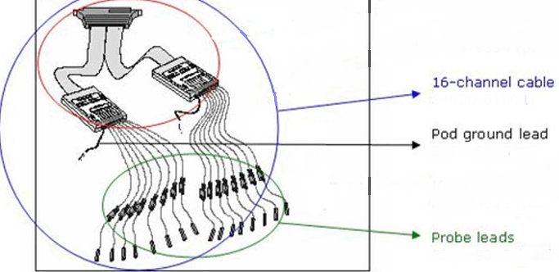

**Figure 5. Logic Analyzer Probes**

* Figure 6 illustrates both analog and digital channels displayed together on the Keysight X 3012A MSO screen. The analog channels are displayed at the top of the screen while the digital channels are displayed below them. It should become clear upon viewing Figure 7 what the differences between analog and digital channels are.

**Digital Channels Shown with Analog Channels**



**Figure 6. Analog and Digital Waveforms**

**Configuring Digital Channels**

A logic analyzer is essentially a multiple channel digital storage scope with many ways to trigger as a troubleshooting aid; it allows the experimenter to observe numerous digital signals at various points in time and thus make decisions based upon such observations.

We will use the logic analyzer (digital input channels of the MSO) to observe of the output signals from ports PF2, PF3 and PF4 of the Tiva Launchpad as configured for Lab Project 1. Figure 7 shows Switch and LED interfaces on the Tiva LaunchPad evaluation board.

# 

**Figure 7. *Switch and LED interfaces on the Tiva LaunchPad Evaluation Board.***

Make the following connections from the Tiva Launchpad ports PF2, PF3 and PF4 (connector picture with ports labels shown below) to the digital input channels 0 through 2 (D0-D2) of the digital logic analyzer probe (see below for a picture) of the MSO:

* The GND of the LaunchPad to the GND connection wire (color in black) of the analyzer probe
* The port labeled ‘PF2’ of the LaunchPad to digital input 0 (D0) of MSO
* The port labeled ‘PF3’ of the LaunchPad to digital input 1 (D1) of MSO
* The port labeled ‘PF4’ of the LaunchPad to digital input 2 (D2) of MSO

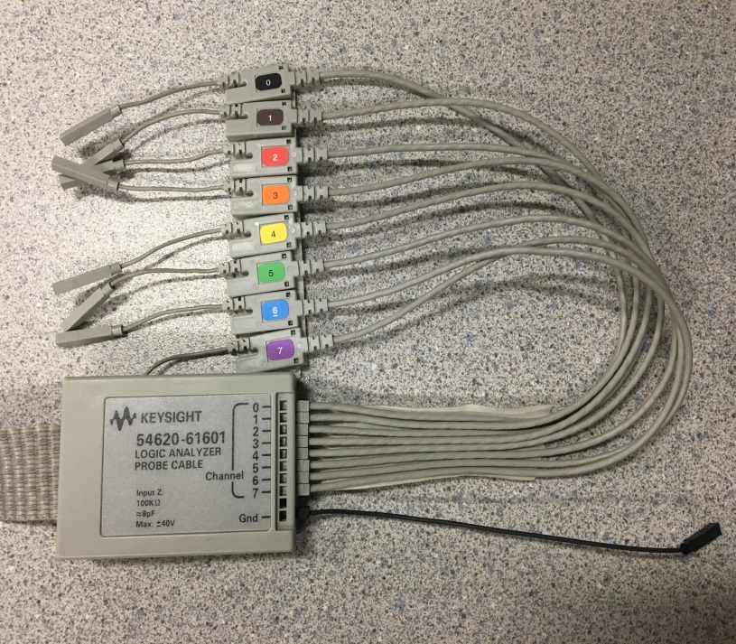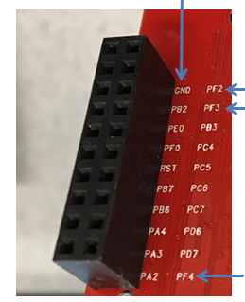

Next, perform the following actions through the front panel of the MSO:

* Verify the threshold level of the digital channels is set to TTL using the following steps:
  + 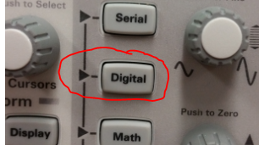Press the key **Digital**
  + 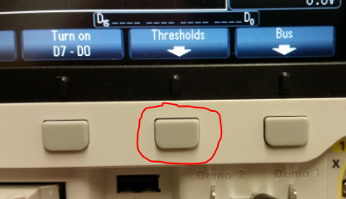Press the button underneath the *Thresholds* option at the bottom of the screen
  + Verify D7-D0 is set to TTL (1.4V)

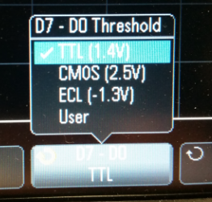

* Turn on digital channels D0 ,D1 and D2 using the following steps:
  + Press the key **Digital**



* + Verify that D7-D0 is turned ‘ON’ and D15-D8 is turned ‘OFF’

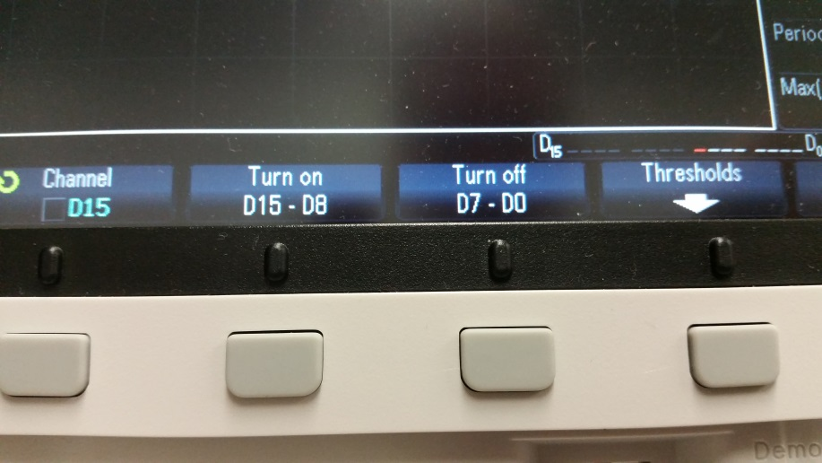

* + Press the button underneath the *Channel* option at the bottom of the screen

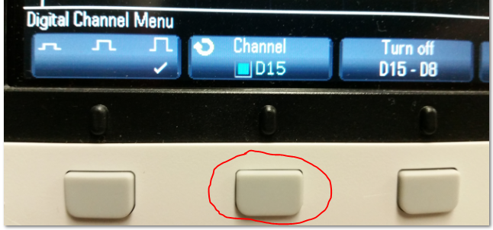

* + Using the **Entry** knob, deselect D3 through D7 and keep D0, D1 and D2 selected
* Press the key **Autoscale**
  + The *Autoscale* key automatically determines which channels have activity and will turn these channels on and scale them to display the signals properly.
* Press the key **Single**
  + The *Single* key allows a user to make single-shot acquisitions of a waveform being displayed on the MSO. This is useful when viewing trigger conditions as well as analyzing a given waveform.

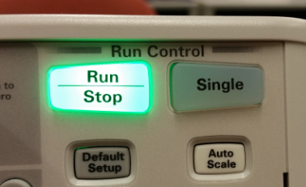

If the previous steps are done correctly, the MSO should auto-recognize the digital inputs on channels D0, D1 and D2. Three waveforms (two straight and one square) should appear similar to those shown in Figure 8 below.

Note: press the SW1 switch on the Tiva LaunchPad to generate the waveforms in Figure 8(b).

(a) 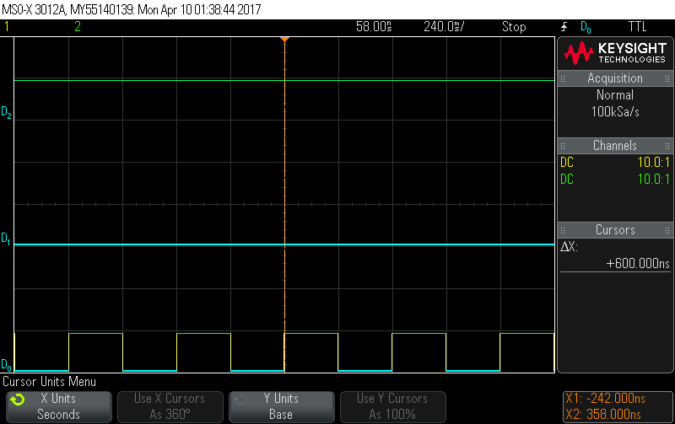**Three Digital Waveforms on Channels D0, D1 and D2**

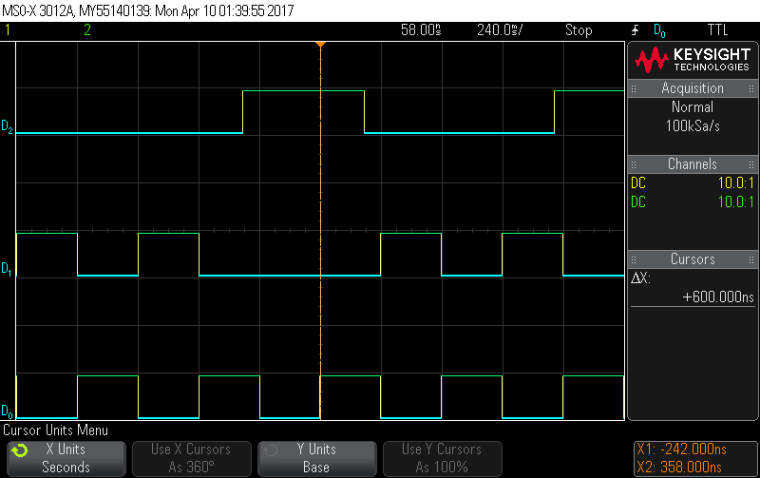

**(b) Three Digital Waveforms on Channels D0, D1 and D3**

**Figure 8. MSO Digital Channels D0, D1 and D2 Connected to Tiva Launchpad Ports PF2, PF3 and PF4**

**Digital Signal Adjustments**

Using the same set of waveforms shown in Figure 8, manipulate the size, Time/Div, and turn one or more signals ‘OFF’ and then back ‘ON.’ The step-by-step instructions on signal adjustment shown below were taken directly from the *Keysight InfiniiVision 3000 X-Series Oscilloscopes User's* Guide. [1]

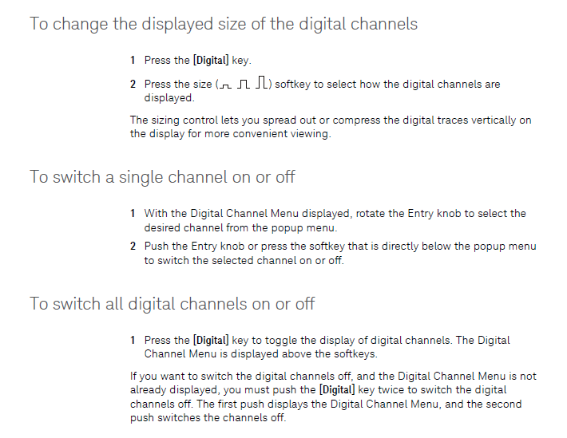

Change the size of either D0 or D1 using the steps listed to the left. What is your observation? How does the signal change? What adjustment is this similar to for analog waveform ‘size’ adjustment?

Practice turning D0 ‘OFF’ and then back ‘ON’ using the steps listed to the left. Why is it important to be able to turn digital signals ‘ON’ and ‘OFF’?

Practice turning D0 and D1 ‘OFF’ simultaneously using the steps listed to the left. Next, turn D0 and D1 back ‘ON’.

Lastly, locate the **Time/Div** knob and rotate it counter-clockwise and clockwise. Observe the waveform during various Time/Div intervals.

* How is the waveform changing?
* Why might it be useful to increase the Time/Div setting in some cases and decrease it in others?

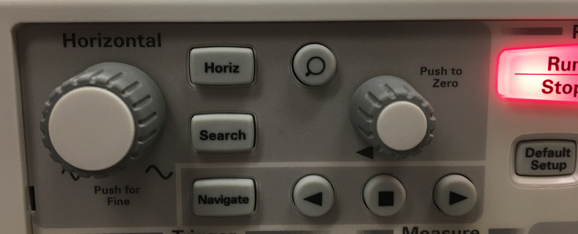

**Channel Labeling**

Assigning a meaningful label as the name of a signal on a particular digital channel helps the user to identify with a specific waveform readily. For example, the default label of digital input channel number one is D1, but the input signal hooked up to D1 may be referred to as the ‘Clock’ in real life. It would benefit the user to change this label to better identify with the MSO waveforms being observed.

The steps listed below outline the procedure to define a new label and were taken directly and adapted from the *Keysight InfiniiVision 3000 X-Series Oscilloscopes User's* Guide. [1]

**Defining a New Label**

**1.** Press the **Label** key.

**2.** Press the **Channel** softkey; then, turn the Entry knob or successively press the softkey to select channel D0, D1 or D2 for label assignment. The digital channels D0, D1 and D2 will be relabeled to TEST1, TEST2 and TEST3 respectively by implementing the steps below. The channel does not have to be turned on to have a label assigned to it. If the channel is turned on, its current label will be highlighted.

**3.** Press the **Spell** softkey; then, turn the Entry knob to select the first character in the new label. In the case of this example the first letter would be ‘T’.

Turning the Entry knob selects a character to enter into the highlighted position shown in the "New label =" line above the softkeys and in the **Spell** softkey. Labels can be up to ten characters in length.

**4.** Press the **Enter** softkey to enter the selected character and to go to the next character position.

**5.** You may position the highlight on any character in the label name by successively pressing the **Enter** softkey.

**6.** To delete a character from the label, press the **Enter** softkey until the letter you want to delete is highlighted, then press the **Delete Character** softkey.

**7.** When you are done entering characters for the label, press the **Apply New Label** softkey to assign the label to the selected channel.

Upon becoming familiar with steps 1-7 above, practice relabeling D0, D1 and D2 to TEST1, TEST2 and TEST3, respectively. If done correctly your labels should look similar to those shown in Figure 9.

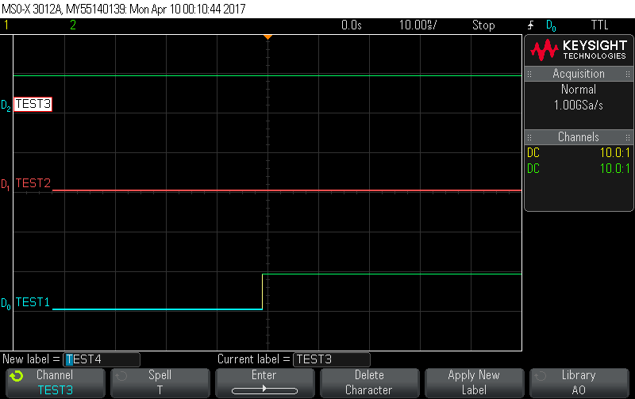

**Figure 9. Channel Labeling of D0, D1 and D2**

**Cursors**

**1.** Use the same square wave signals previously used at the D0 (TEST1), D1 (TEST2) and D2 (TEST3) inputs to practice the use of cursors. Be sure to press the **Single** key in order to ‘freeze’ the waveforms in time.

**2.** Once the two square waves are present on the oscilloscope screen, press the **Cursors** key. The Cursors box in the right-side information area appears, indicating that cursors are ‘ON’. (Press the **Cursors** key again when you want to turn cursors ‘OFF’.)

**3.** In the Cursors Menu, press **Mode**; then, select the *Manual* option.In the *Manual* mode, ΔX, 1/ΔX, and ΔY values are displayed. ΔX is the difference between the X1 and X2 cursors and ΔY is the difference between the Y1 andY2 cursors.

**4.** Push the **Cursors** knob; then, turn the **Cursors** knob to select the desired cursor, **X1, X2, X1** **X2 linked, Y1, Y2, or Y1 Y2 linked.** The **X1** and **X2** cursors denote vertical cursor lines while the **Y1** and **Y2** cursors denote horizontal cursor lines. The **X1 X2 linked** and **Y1 Y2 linked** selections let you adjust both cursors at the same time, while the delta value remains the same. This can be useful, for example, for checking pulse width variations in a pulse train. The currently selected cursor(s) display brighter than the other cursors.

For this particular example, the **X1** and **X2** cursors will be utilized. The menu that appears when the **Cursors** knob is pushed is shown below.

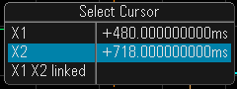

**5.** First, select the **X1** cursor by turning the **Cursor** knob to place the blue highlight over **X1**. To finalize your selection, either push the **Cursors** knob again or wait about five seconds for the popup menu to disappear. Use the **Cursor** knob to position the **X1** cursor at the first visible high-to-low transition point in either the TEST1 or TEST2 square waveforms.

**6.** Next, select the **X2** cursor by turning the **Cursor** knob to place the blue highlight over **X2**. To finalize your selection, either push the **Cursors** knob again or wait about five seconds for the popup menu to disappear.

**7.** Lastly, use the **Cursor** knob to position the **X2** cursor over the next high-to-low transition point of the same waveform used for **X1**. Consult Figure 10 for a visual example of the previously described steps. Notice that the distance between cursors **X1** and **X2** represents ΔX and is the period of the waveform. The reciprocal of ΔX is the frequency of the waveform. In this particular example, the period is equal to 484 ms and the frequency is equal to 2.066 Hz. These values are also displayed at the bottom right of the image shown in Figure 10.

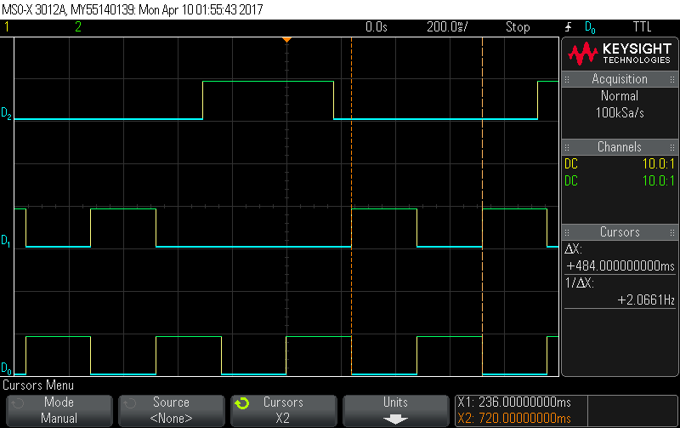

**Figure 10. Cursor Placement**

**Triggering Modes**

Triggering refers to the satisfaction of a condition (such as a signal changing its level from low-to-high or vice versa) which is used to initiate the capture of logic signals being monitored through the digital channels. Trigger indicates the use of a certain attribute of a logic signal or signal set being monitored. Triggering can be based on

* a specific signal changing levels (transitions from low-to-high indicating rising edge or high-to-low indicating a falling edge),
* a specific signal attaining a certain level (logic low vs. logic high) or
* a set of signals assuming a specific value combination (pattern trigger).

Set the triggering mode of the Keysight MSO-X 3012A to “*edge then edge*” trigger using the steps below.

* Press the key *Trigger*
* Press the button underneath the *Trigger Type* option
* Select the *edge then edge* option using the selection knob to the right of the screen
* Next, press the button underneath the *Sources* option
* Press the button *Arm A* option Select *D2*
* Press the button *Slope A* option Select *Rising*
* Press the button *Trigger B* option Select *D2*
* Press the button *Slope B* option Select *Falling*
* Press the key labelled as *Single*.
* Press SW1 on the Tiva LaunchPad and release.

Adjust the result to display at least one cycle or more. Were you successful in implementing the above steps and does your result make sense? Consult Figure 11 to visualize what the correct operation of the circuit should look like. Verify your results with your lab instructor.

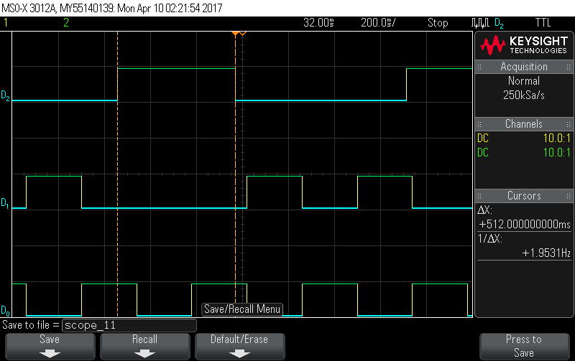

**Figure 11. “Edge then Edge” trigger**

**Saving Information**

The Keysight MSO-X 3012A allows users to save information using two different methods. A waveform can be captured and saved from the oscilloscope to a connected computer or by utilizing the on-board USB slot. The BenchVue utility is the software on the computer that the MSO communicates with and it allows waveforms to be saved to a desired location. The USB saving option can be used when it is only necessary to save oscilloscope data to a removable media drive. The steps listed below outline the steps to save a waveform and were taken directly from *Keysight InfiniiVision 3000 X-Series Oscilloscopes User's* Guide. [1]

**USB Drive**

**1.** Insert storage medium of choice into the front USB port of the MSO. Press the **Save/Recall** key.

**2.** In the Save/Recall Menu, press the **Save** softkey.

**3.** In the Save Menu, press the **Format** softkey and turn the Entry knob to select

**PNG 24-bit image(*.png)**

**4.** Press the **Save** to softkey, then select the desired saving location.

**5.** Once a location is specified, press the **File Name** softkey to change the name of the file.

**6.** Finally, press the **Press to Save** softkey.

A message indicating whether the save was successful is displayed.

**BenchVue Utility**

**1.** Make sure the MSO is turned ‘ON.’

**2.** Open the Keysight BenchVue program installed on the computer.

**3.** The oscilloscope icon should appear at the bottom right of the BenchVue welcome screen if there is an established connection between the computer and MSO. Double-click this icon to bring up the main screen of the BenchVue utility. See Figure 12 for reference.

**4.** In order to capture the waveform/s displayed on the oscilloscope, the ‘Get Current Screen’ button shown at the top left of the BenchVue interface must be selected. The button is circled in Red in Figure 12.

**5.** To save a waveform once it has been captured to the BenchVue utility, select the save icon at the bottom right of the screen and then select ‘Save Image’. The icon is circled in blue in Figure 12.

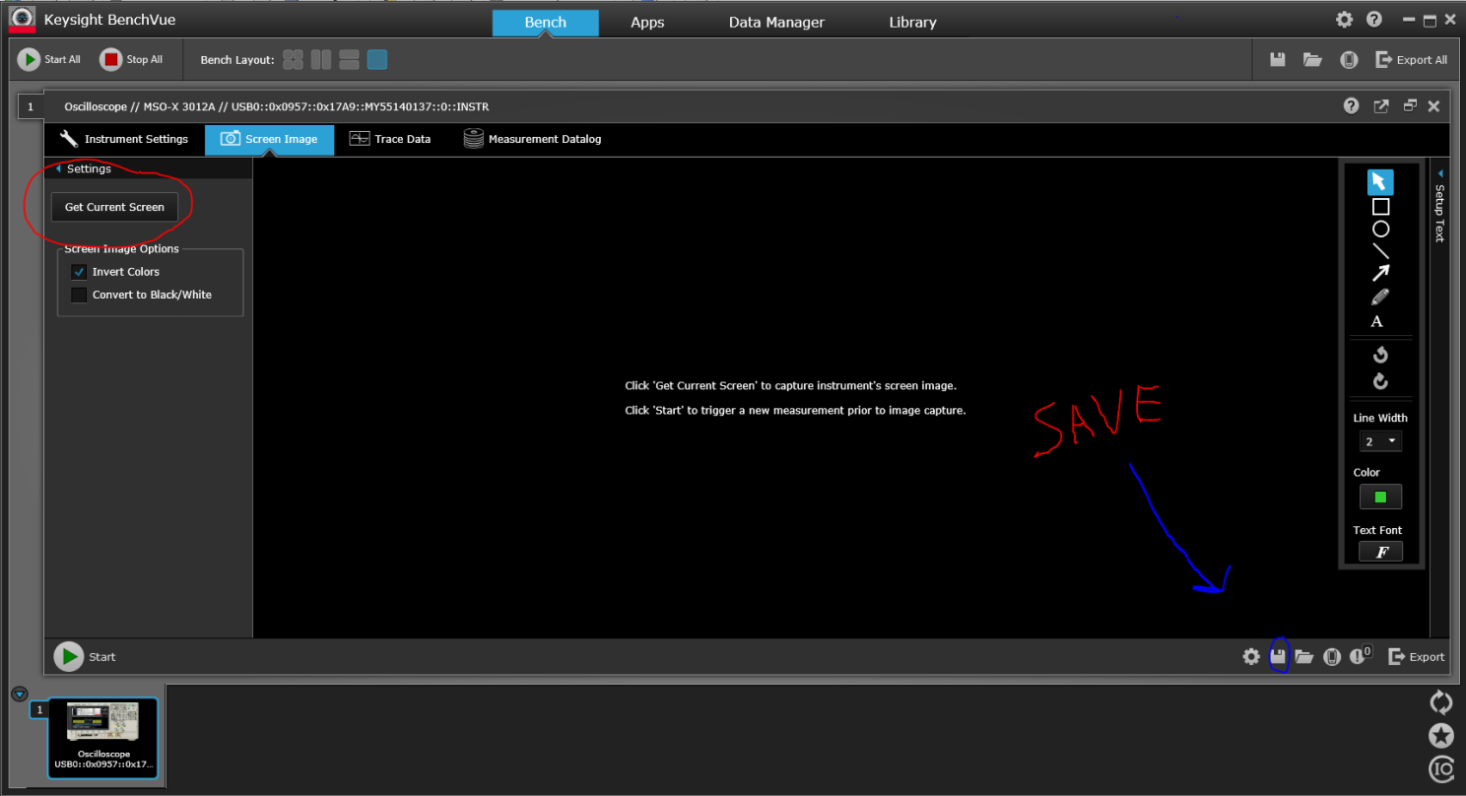

**Figure 12. BenchVue Utility Graphical User Interface (GUI)**

**6.** Save the file as the desired name and to the location of choice. Refer to Figure 13.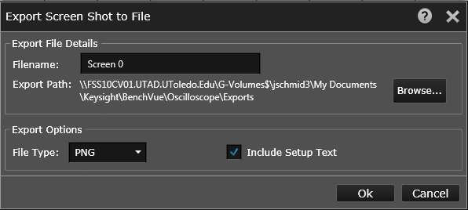

**Figure 13. Saving Menu**

**APPENDIX**

**Keysight MSO Interface Explained**

The table below outlines the various components of the oscilloscope interface shown in Figure 14. All page references mentioned in the table can be found in the *Keysight InfiniiVision 3000 X-Series Oscilloscopes User's Guide.* [1]



[1] Keysight InfiniiVision 3000 X-Series Oscilloscopes User's Guide. (2013). In (Eighth ed., Vol. One, pp. 1-430). Colorado Springs, Colorado: Keysight Technologies.

**Figure 14. Keysight MSO Overview**

